Fall River Resource Conservation District
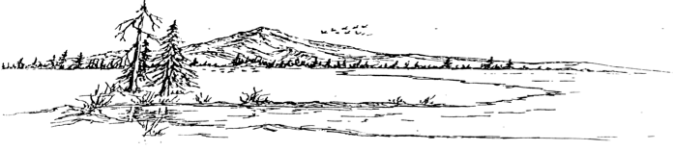
^{e-m}

BOARD MEETING AGENDA
Meeting Agenda - Tuesday, February 18th, 2025 at 5:00 PM
At the RCD Office Building in McArthur

Call Meeting to Order

Public Comment
Any person may address the board at this time about any subject within the jurisdiction of the Fall River Resource Conservation District; however, any matter that requires action will be referred to staff for a report and approve action at a subsequent meeting.

New Business
Scholarships

Old Business
McArthur Swamp Pivot
Office Building - NRCS

Consent Calendar
Minutes January 21, 2024 Regular Meeting
Expenditures 12/20/2024 – 02/18/2025
Financial Reports including Profit and Loss, Balance Sheet, Transaction Reports, and Reconciled Bank Statements.

Executive Directors Report
Grant Status Report
Indirect Expense Report
Forest Service Small Land Owner Grant Award
Meeting w/ Doug LaMalfa
Liability Insurance
OPR Position
ACL Conference

Range Managers Report
Gun Club Building Envelope
Weed Management Area Funding
McArthur Swamp Water Rights
Range Manager Position

Adjourn:
At any time during the regular session, the Board may adjourn to a closed session to consider litigation, personnel matters, or to discuss with legal counsel matters within the attorney/client privilege and it may be held in a closed session. Authority: Government Code Section 1126(a)(d)(g)

Next Regular Meeting Date – Tuesday, March 18th, 2025 – Beginning at 6:00 PM

