Fall River Resource Conservation District
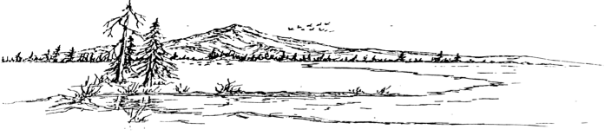
^{e-m}

BOARD MEETING AGENDA
Meeting Agenda - Tuesday, October 15th, 2024 at 6:00 PM
At the RCD Office Building in McArthur

Call Meeting to Order

Public Comment
Any person may address the board at this time about any subject within the jurisdiction of the Fall River Resource Conservation District; however, any matter that requires action will be referred to staff for a report and approve action at a subsequent meeting.

New Business
Shasta Land Trust Invoice/Easement Amendment
Fall River Lake Property - Access

Old Business
Fall River Lake Duck Blinds

Consent Calendar
Minutes September 17th, 2024 Regular Meeting
Expenditures 09/17/2024 – 10/15/2024

Executive Directors Report
Skid Steer
UA Local 228 Interaction
FS Small Landowner Grant
Indirect Update/ Grant Status Report
BFP Status

Range Managers Report
Gun Club Property
DU Well and Pipeline
McArthur RD Pivot
Partners Project Updates
Game Bird Club License/Pheasant Hunt

Adjourn:
At any time during the regular session, the Board may adjourn to a closed session to consider litigation, personnel matters, or to discuss with legal counsel matters within the attorney/client privilege and it may be held in a closed session. Authority: Government Code Section 1126(a)(d)(g)

Next Regular Meeting Date – Tuesday, November 19th, 2024 – Beginning at 6:00 PM

